|  |  |
| --- | --- |
| Team ID | PNT2022TMID07522 |
| Project Name | Smart Farmer-IOT Enabled smart  Farming application |

IBM Cloud services

Dashboard

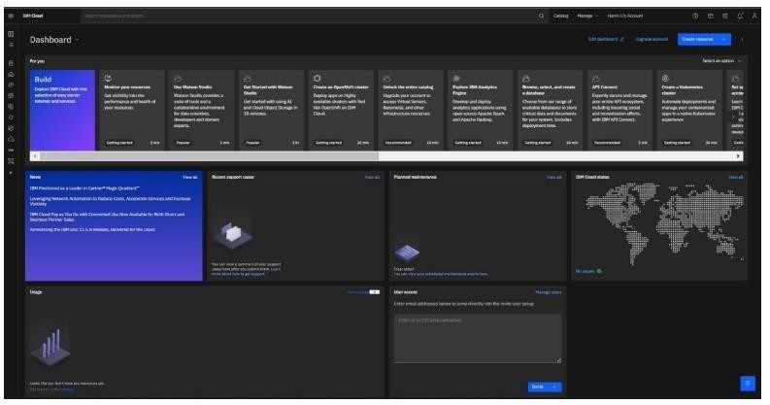

Account Settings

